GATHER

Community Needs and Resource Assessment

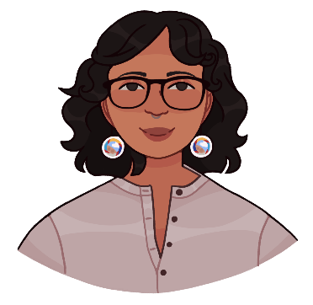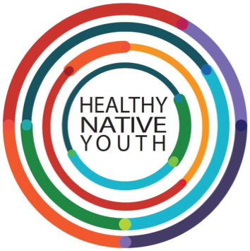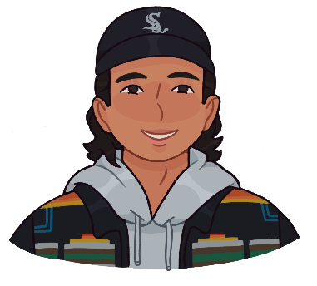


Use the “Community Needs and Resource Assessment” to help organize your outreach while you meet with partners to identify health priorities. There are several options included in the template that you can use to engage partners in the planning process, depending on your setting and audience. You will likely need different strategies to collect feedback from different audiences and age groups.

The goal of a community needs and resource assessment is to understand:
- What youth, their families, and the broader community want to see in youth programming
- What resources you have available to your program,
- What constraints or challenges may need to be addressed

To assist you in the process, we have included a planning template that walks you through the following steps.
Step 1: Selecting Who to Engage in the Planning Process and How Best to Reach Them
Step 2: Questions to Discuss
Step 3: Sharing Your Findings

Instructions: Use this template to guide your planning process.

Source: Adapted from Trevino, N., & Gaston, A. 2020. Healthy Native Youth: Virtual Adaptation Guide. Portland, OR: Northwest Portland Area Indian Health Board. Section 1.1 Community Needs Assessment Planning.

Step 1: Selecting Who to Engage in the Planning Process and How Best to Reach Them

Guiding Question: Who should provide feedback, input and guidance on the program?

Activities | Select Audience | Who’s Involved
Select Audience | - Youth  - Parents, Families, and Caring Adults  - Elders or Tribal Leaders  - Community Members  - Schools or Other Implementation Sites  - Partner Organizations  - Other (List)

Guiding Question: How do you want to gather that feedback?

Activities | Select | Who’s Involved
Select Methods to Gather Feedback | Paper or Document  - In-Person Form or Survey  - Mail Survey – include Self-addressed envelope  - Email Attachment or Emailed Questions  Electronic  - Social Media Poll  - Survey Link or Online Form (e.g., Survey Gizmo, Survey Monkey, Qualtrics, etc.)  - Zoom Breakout Rooms, Poll feature  - Other:  Interview  - In-person  - Phone or Online

Guiding Question: Where will you gather input and ideas?

Activity | Select Event(s) | Location(s) | Date(s) & Time | Contact Person
Identify Opportunities for Feedback | - Youth Event  Name:
Identify Opportunities for Feedback | - School Event  Name:
Identify Opportunities for Feedback | - Community Event  Name:
Identify Opportunities for Feedback | - Tribal Event  Name:
Identify Opportunities for Feedback | - Parent Event  Name:
Identify Opportunities for Feedback | - Cultural Event  Name:
Identify Opportunities for Feedback | - Create Own Event  Name:
Identify Opportunities for Feedback | - Other  Name:

Tip: Consider offering incentives to those who participate, like Gift Cards (Amazon, Walmart, iTunes, etc.), Food Cards (Starbucks, Restaurant, GrubHub, etc.), or Project Swag (hoodies, shirts, stickers, etc.).

Step 2: Questions to Discuss

Below are some sample questions that can be used for conversations, surveys, or meetings with community partners. The questions are split up into different audience groups, for your consideration.
The questions could be emailed, put into a survey tool (e.g., Survey Gizmo, Survey Monkey, etc.), or asked verbally in-person or virtually (e.g., Zoom, Google Classroom, MS Teams, etc.).
You can get creative and use interaction tools to collect responses, like Padlet, Quizlet, Mentimeter, or Zoom polls…or even do a Bingo Data Collection activity.
Below you can find sample questions for:
- Youth
- Improving Clinic Services for Youth
- Parents and Caregivers
- Schools and School Administrators
- 2SLGBTQ Community Readiness

Sample Q’s for Youth

Health Priorities and Ideas
- What health topics are most important to you and your friends right now?
- What health resources do you and your friends use in the community?
- Are there any you avoid? Why?
- What additional health resources do you wish our community had?
- What ideas do you have that would make the health resources in our community better for teens and young adults?

Logistics
- When are you available to participate in youth programs?
  - Weekend Mornings
  - Weekend Evenings
  - Weekday Afternoons
  - Weekday Evenings
  - Other, please describe:
- What is the best way to tell you about youth programs?
  - Email
  - Mail
  - Online Learning App
  - Social Media
  - Text Message/Phone Call
  - Other, please list

Virtual Platform (IT Capacity)
- What equipment do you have for online learning/programs (Check all that apply)?
  - Cell phone
  - Smart phone
  - Tablet
  - Laptop, computer
  - Other, please list:
- Do you have internet access?
  - Yes, unlimited
  - Yes, limited
  - Some of the time
  - No access at home
  - No access at all
- What virtual platforms do you like using?
  - Zoom
  - Google classroom
  - Teams
  - FB/ IG Live
  - Other, please list

Temperate Check
- What challenges are you having right now?
- What is going well for you?
- What skills or topics are you interested in learning about?

Sample Q’s to Improve Clinic Services for Youth

Adapted from the Teen-friendliness Clinic Survey from Native It’s Your Game.
*Check out Healthy Native Youth for the BINGO Data Collection activity.
- What hours or days would you recommend the clinic be open to make it easier for teens to schedule appointments?
- Can teens receive an appointment the same week they call?
- How teen-friendly do you think clinic waiting rooms are?
- How LGBTQ2S friendly do you think clinic waiting rooms are?
- Would you recommend any changes to clinic signs to be more inclusive for teens, LGBTQ2S youth, or Indigenous languages speakers?
- Where would you recommend information be posted that assures youth their information is kept private and confidential, as well as the assurance they will be seen, even if they are not able to pay for their services?
- Do you provide transportation for teens to get to the clinic?
- What teen-friendly magazines, music, games, or LGBTQ2S materials would you suggest for the waiting room?
- What pamphlets or health education materials or topics would you recommend the clinic display?
- What recommendations would you give to make clinic forms more teen-friendly?
- In what ways could clinic staff better support teens during their appointment?
- Where could condoms be confidentially stored?
- What recommendations would you give for clinic staff to build ongoing professional health care relationships with teens?

Sample Q’s for Parents and Caregivers

Health Priorities and Ideas
- What health topics are most important to your kids/family right now?
- What health resources does your family use in the community?
- Are there any you avoid? Why?
- What additional health resources do you wish our community had?
- What ideas do you have that would make the health resources in our community better for teens and young adults?

Logistics
- What other activities do your youth participate in? How often?
  - Sports
  - Tribal Events
  - Faith Based Events
  - After school programs
  - Other, please list
- What is the best way to tell you about youth programs and events?
- Email
- Mail
- Social Media
- Text Message/Phone Call
- Other, please list:

Temperate Check
- What type of health and wellness programs would your youth be interested in?
- What challenges is your youth/family experiencing right now?
- What are some of your youth’s strengths that you want to nurture?
- What type of programs or services would be helpful for your family?
- What type of support would be helpful for you as a parent/caregiver?

Sample Q’s for Schools and School Administrators

Health Priorities and Ideas
- What health topics are most important to your students/families right now?
- What additional health resources do you wish your school had?
- What ideas do you have that would make the health resources at your school better for teens and young adults?

Logistics/Plans for Implementation
- Does your district have a ‘back-to-school’ schedule? If so, please share.
- Is your school planning to utilize a traditional, virtual, or blended learning format?
- Will your school be utilizing asynchronous, synchronous, or both types of learning?
- At what frequency will this type of learning be offered?
- Are you currently allowing community-based organizations to implement programs in your school?
- How does your school communicate with parents?
- Would in-person or virtual programs for youth be preferred?

Virtual Platform (Internal Staff Capacity/Training)
- What virtual platforms will the district be using (e.g., zoom, google classroom, teams, etc.)

Temperate Check
- What type of programs or services would be helpful to your school?
- What type of support would be helpful for your teachers?

Sample Q’s for 2SLGBTQ Community Readiness
*Check out Healthy Native Youth for the Full Guide & the recorded Community of Practice Session from 2/12/20.

- Why do you think it’s important for Native youth to learn about 2SLGBTQ topics (e.g., terminology, history of Two-Spirit, safety, acceptance, resources, etc.)?
- At what age should 2SLGBTQ education begin?
- What topics are important for youth to learn about 2SLGBTQ inclusion?
- Do you think 2SLBGTQ youth are comfortable talking about their sexual orientation or gender identity with teachers and other youth at your school?
- If you hear a comment that is negative about 2SLGBTQ identities, are you comfortable speaking up to disagree with or correct that comment?
- Does your school, community center, or other buildings have gender-neutral restrooms?
- What programs, clubs, or services exist in your community for 2SLGBTQ youth?
- Can 2SLGBTQ youth in your community participate in gender-neutral (co-ed) sports teams or in the sports team that aligns with their gender identity?
- What are the barriers for an 2SLGBTQ inclusive program in your community? How can they be overcome?
- What health services (e.g., reproductive health, substance use, mental health) are available to 2SLGBTQ youth in your community?
- How easy/hard is it for 2SLGBTQ youth to access these services confidentially? How could this be improved?
- Anything else we should know?

Step 3: Share Your Finding
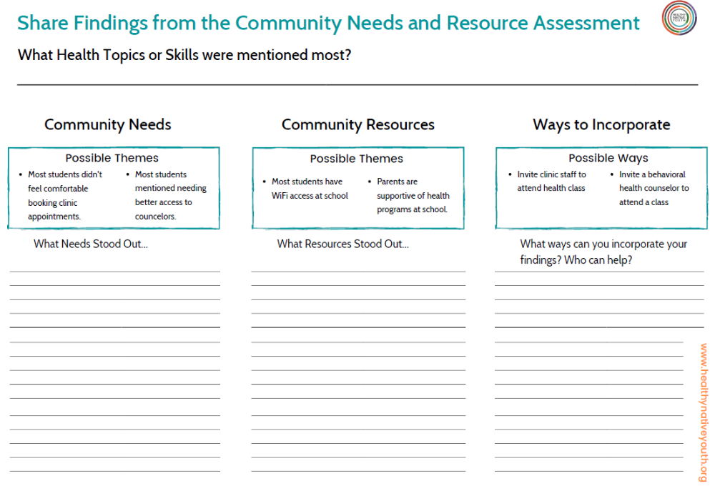
Once you have gathered input from community partners, you will want to share your findings back with those who contributed to it.

