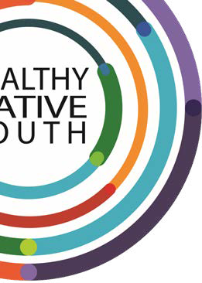
Healthynativeyouth. org 1


2SLGBTQ Community Readiness Survey
Created for Healthy Native Youth in partnership with our Community of Practice friends from NAYA Two Spirit Safe Space Alliance and the Pascua Yaqui Tribe.
Healthynativeyouth. org

2SLGBTQ Community Readiness Survey
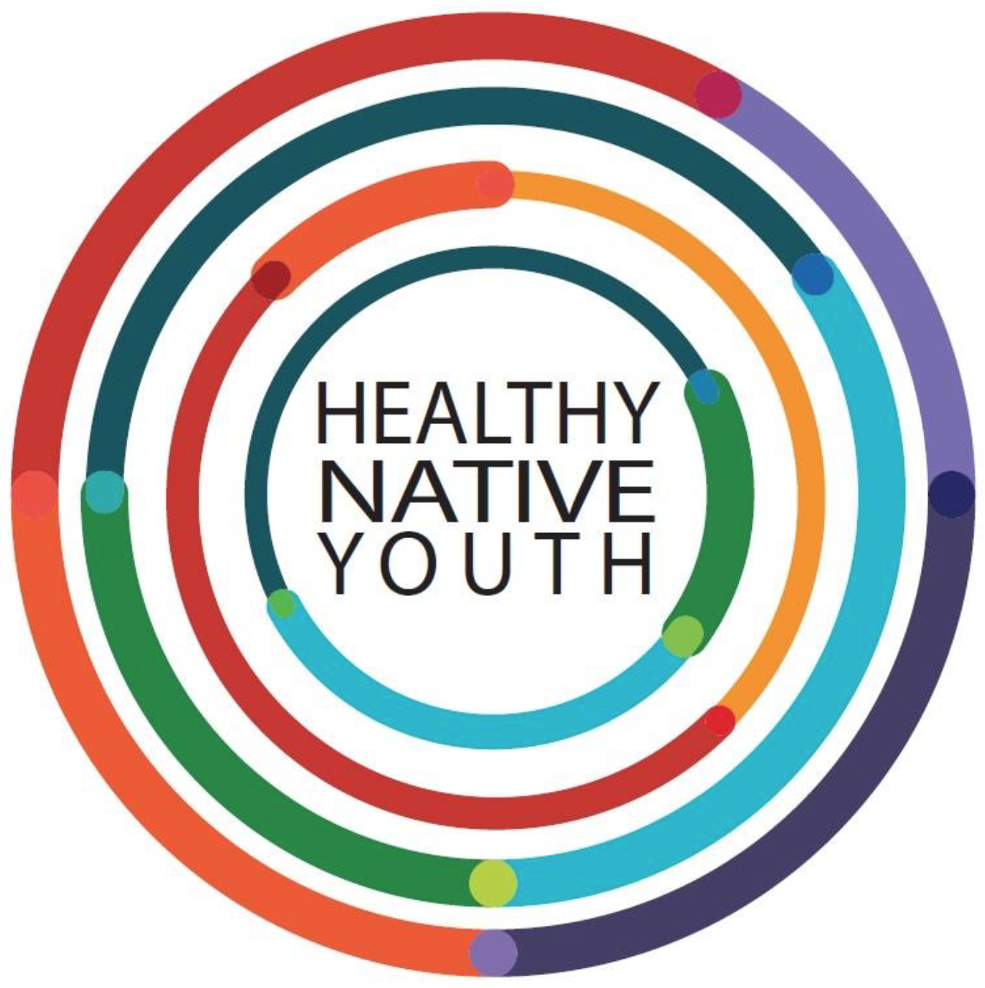

Goal of Community Readiness Survey:
To successfully integrate the voice, expertise, and resources from all community members to improve the health and well-being of our 2SLGBTQ youth.
Step 1: Identify community gatherings where 2SLGBTQ readiness survey can be distributed
Step 2: Distribute & Collect Survey
Step 3: Integrate survey results into current programming

Step 1: Identify Community Gatherings
- Check the events that you can either host or co-host to collect community feedback on the current inclusion of Two Spirit and LGBTQ youth:
- Youth Events  List with dates/ times:  - School Events  List with dates/ times:  - Community Events  List with dates/ times: | - Tribal Events  List with dates/ times:  - Parent Nights  List with dates/ times:  - Cultural Nights  List with dates/ times:

Whose Voice is Missing?
Every single member of your community has expertise they can share that can strengthen 2SLGBTQ youth programming and resiliency skills. This can help to identify where you can fill in the gaps.

- Check ways that you could reach out and invite folks. Who can help you make that happen?

Reach Community Members (Invite Strategy) | Who’s Responsible?
- Newspapers/ Tribal Newsletter
- Local or Tribal Radio Station
- Social media
- Partner Channels (e.g. school, tribal clinic, Boys&Girls Club, etc.)
- Tribal Grapevine
- Email
- Other ways:

- Review your list from # 1 and identify which events you will plan to distribute and collect the community readiness surveys.

Where are good places to collect survey data?
Event | Invite Strategy | Who can help organize? | Contact Info

- What materials will you need to gather or make arrangements for?
  - Tables/ chairs
  - Sign-in Sheets
  - Audio equipment (e.g. projector/ screen, mic/ speakers, if needed)
  - Refreshments
  - Incentives/ raffles/ program swag/ brochures/ flyers
  - Transportation

Step 2: Distribute & Collect Survey

Survey Procedures
This community readiness survey was created to learn the feelings and level of comfort of your community members regarding 2SLGBTQ topics and program inclusivity.
Before you distribute the survey, provide:
- A brief summary
- Survey instructions
- Next steps

Provide Brief Summary
Introduce yourselves. I want to thank each of you being here to fill out the 2SLGBTQ Community Readiness survey.

Your honest answers will help us identify community strengths and needs, as well as provide a better understanding of where a good starting point would be for being more 2SLGBTQ inclusive in our programming and services.

The survey will take about 10 minutes to complete and is anonymous. Your help is VERY IMPORTANT to us.
We want to say a HUGE thank you for helping us today!

Survey Instructions
Please fill in the top portion of the survey, which includes your role in youths lives, their age group, and your
profession.
Please fill in the survey questions and bring them to me (or other helpers) when complete. If you’d like to stay informed and involved, please fill out the sign-in sheet when you’re done.

Next Steps
Once we’ve gathered everyone’s surveys, we’ll look closely at all the responses. We will take time to identify our strengths and areas of need to inform how we will approach incorporating 2SLGBTQ inclusivity, based on where our community is at today. We will report the results back to the community (insert – e.g. newsletter, community event, social media, etc. Also, insert any info about collecting ‘thank you’ gifts or survey incentives, if applicable).

Are there any questions before we begin?

2SLGBTQ Community Readiness Survey
This community readiness survey was created to learn your feelings regarding 2SLGBTQ inclusivity and education for Native youth. If you would like to participate, please fill out the top portion of this sheet and complete the following questions. Many Thanks!

Please Fill in:
Your Role in youth’s life: Age Group(s) of Youth:
(e.g. parent, caregiver, auntie, uncle, grandparent, relative, neighbor, etc.) (e.g. elementary, middle, high, college)

Profession:

Why do you think it’s important for Native youth to learn about 2SLGBTQ topics (e.g. terminology, history of Two-Spirit, safety, acceptance, resources, etc.)?

At what age should 2SLGBTQ education begin?

What topics are important for youth to learn about 2SLGBTQ inclusion?

Do you think 2SLBGTQ youth are comfortable talking about their sexual orientation or gender identity with teachers and other youth at your school?

If you hear a comment that is negative about 2SLGBTQ identities, are you comfortable speaking up to disagree with or correct that comment?

Does your school, community center, or other buildings have gender-neutral restrooms?

What programs, clubs, or services exist in your community for 2SLGBTQ youth?

Can 2SLGBTQ youth in your community participate in gender-neutral (co-ed) sports teams or in the sports team that aligns with their gender identity?

What is the best way to engage community members in an 2SLGBTQ inclusive program?

What are the barriers for an 2SLGBTQ inclusive program in your community? How can these best be overcome?

What health services (e.g., reproductive health, substance use, mental health) are available to 2SLGBTQ youth in your community?

How easy/hard is it for 2SLGBTQ youth to access these services confidentially? How could this be improved?

Anything else we should know?

Sign-in Sheet & Community Calendar

Name & Role  (e.g. youth, parent or guardian, Elder, prevention specialist, profession, etc.) |  | E-mail & Phone Number  *Please write down any future community events you’re involved with. | What talents could you share?  (e.g. traditional art/ stories, volunteer, tutoring, mentoring, discussion or planning groups, prepping materials, meal prep, etc.)
1
2
3
4
5
6
7

Step 3: Integrate

Interpret Survey Results
As important as letting your community know that what they think and feel matters, it’s just as important to handle their feedback with integrity.

- Go through each survey and score your communities level of readiness.

Interpreting Survey Results
Go through each survey. For each question, use your best judgement to rank each response based on the examples given. Score with a tally mark under each level of readiness. Then, total up your tally marks to see which level of readiness your community is at.
Survey Questions | Level 1  LOW Level of Inclusion  You might see responses like:  - “I don’t think it’s important.”  - “I don’t know anything about 2SLGBTQ programming.”  - “I don’t think there should be any 2SLGBTQ programming.”  - “There aren’t any 2SLGBTQ youth here.” | Level 2  MEDIUM Level of Inclusion  You might see responses like:  - “I think it’s somewhat important.”  - “I don’t know a lot, but I would like to know more about 2SLGBTQ programming.”  - “I think there should be 2SLGBTQ programming, but only when they’re much older.”  - “I think there might be 2SLGBTQ youth here, but I don’t see them.” | Level 3  HIGH Level of Inclusion  You might see responses like:  - “I think this is incredibly important.”  - “I know a lot about 2SLGBTQ programming, and I would still like to learn more.”  - “I think 2SLGBTQ programming should start as early as possible.”  - “I see 2SLGBTQ youth living openly with strong community support.”
Why do you think it’s important for Native youth to learn about 2SLGBTQ topics (e.g. terminology, history of Two-Spirit, safety, acceptance, resources, etc.)?
At what age should 2SLGBTQ education begin?

What topics are important for youth to learn about 2SLGBTQ inclusion?

Do you think 2SLBGTQ youth are comfortable talking about their sexual orientation or gender identity with teachers and other youth at your school?
If you hear a comment that is negative about 2SLGBTQ identities, are you comfortable speaking up to disagree with or correct that comment?
Does your school, community center, or other building have gender-neutral restrooms?
What programs, clubs, or services exist in your community for 2SLGBTQ youth?
Can 2SLGBTQ youth in your community participate in gender-neutral (co-ed) sports teams or in the sports team that aligns with their gender identity?
What is the best way to engage community members in an 2SLGBTQ inclusive program?

What are the barriers for an 2SLGBTQ inclusive program in your community? How can these best be overcome?
What health services (e.g., reproductive health, substance use, mental health) are available to 2SLGBTQ youth in your community?
How easy/hard is it for 2SLGBTQ youth to access these services confidentially? How could this be improved?
Anything else we should know?
Total Scores:

- Now that you have a sense of where your community is at, go through each survey again and categorize the results into 1) Areas of Strengths, 2) Areas of Need, and 3) how you will utilize and incorporate that information…and who might be able to help.

Incorporate Community Feedback
Areas of Strength | Areas of Need | Ways to Incorporate | Who can Help?

Based on your communities’ level of readiness, find ways your community can be further 2SLGBTQ inclusive:

Levels of Community Readiness | Example Activities for 2SLGBTQ Inclusivity
Level 1 – Just Getting Started  Your community is just getting started. There is not a lot of visibility in terms of 2SLGBTQ signs nor 2SLGBTQ friendly or advocating behaviors or inclusive language or programming.  For pins, email Morgan Thomas at mthomas@npaihb.org | 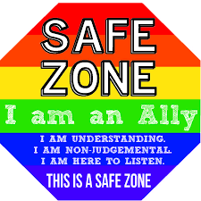  Visibility & Acceptance  Improve strategies for increased visibility and acceptance. For example, posters, pins, active witnessing/bystanding behavior, Two Spirit training from Two Spirit Elders.
  Encourage Community to Do Their Internal Work: Become an Ally
  Suspend Judgements, be they from society or religion
  Seek Knowledge in order to Resource and Educate yourself
  Learn Language  https://pflag.org/glossary | - Gender Identities  - Sexual Identities
  Find stories of Individuals to build empathy and compassion | - Documentaries: There’s Heart Here, Decolonize Love, Fire Song, etc.  - Podcasts: All My Relations, Gender Reveal  - Support Art, Culture and Music of 2SLGBTQ folx in your community
  Trainings and Workshops locally and online | - Aorta  - Montana Two Spirit Society  - Family Acceptance Project
  Free Posters/ Materials | - Corn Pins & Pronoun Pins. Email Morgan Thomas at mthomas@npaihb.org  - We R Native – Two Spirit Loved & Accepted  - Trans Student Educational Resources  - Native Youth Sexual Health Network
Levels of Community Readiness | Example Activities for 2SLGBTQ Inclusivity
Level 2 – We’re Getting There  You may notice your community is working towards being more inclusive by incorporating some infrastructure like gender-neutral restrooms and safe 2SLGBTQ events.  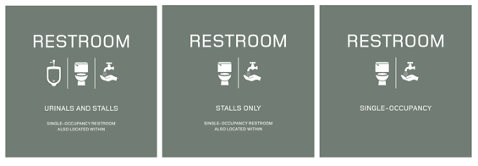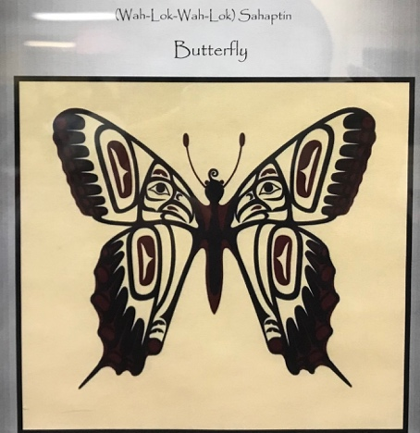 | Support  Increase inclusion by connecting youth to support groups and supporting infrastructure like gender-neutral restrooms and safe and growth-oriented gatherings and 2SLGBTQ friendly events.
  Encourage Community to Do Their External Work: Being an Accomplice for Systemic Change
  2SLGBTQ Support Groups | - GSAs for 2SLGBTQ youth  - Attend a Pflag Meeting  - Ensure sports teams are gender-affirming or co-ed
  Texting resource | - Text ALLY to 97779  - Text 2SLGBTQ to 97779
  Watch | Queer Kid Stuff Video series
  Create visibility of Safer Spaces | Signage, Pins, Ensuring Magazines available
  Interrupt homophobia and transphobia | - Using pronouns proactively  - Asking others for their pronouns and name, ensuring those are respected  - Identifying Gender Neutral toilets and single user toilets and ensuring there is signage for folx use
  Systemic Change | Ensure sex education is 2SLGBTQ inclusive  - Tribal Equity Toolkit  - Indigenzing+Love Toolkit
Levels of Community Readiness | Example Activities for 2SLGBTQ Inclusivity
Level 3 – Let’s Celebrate  You may notice a lot of community support where the visibility of the 2SLGBTQ community is high and there is a general acceptance of growth-oriented gatherings and events.  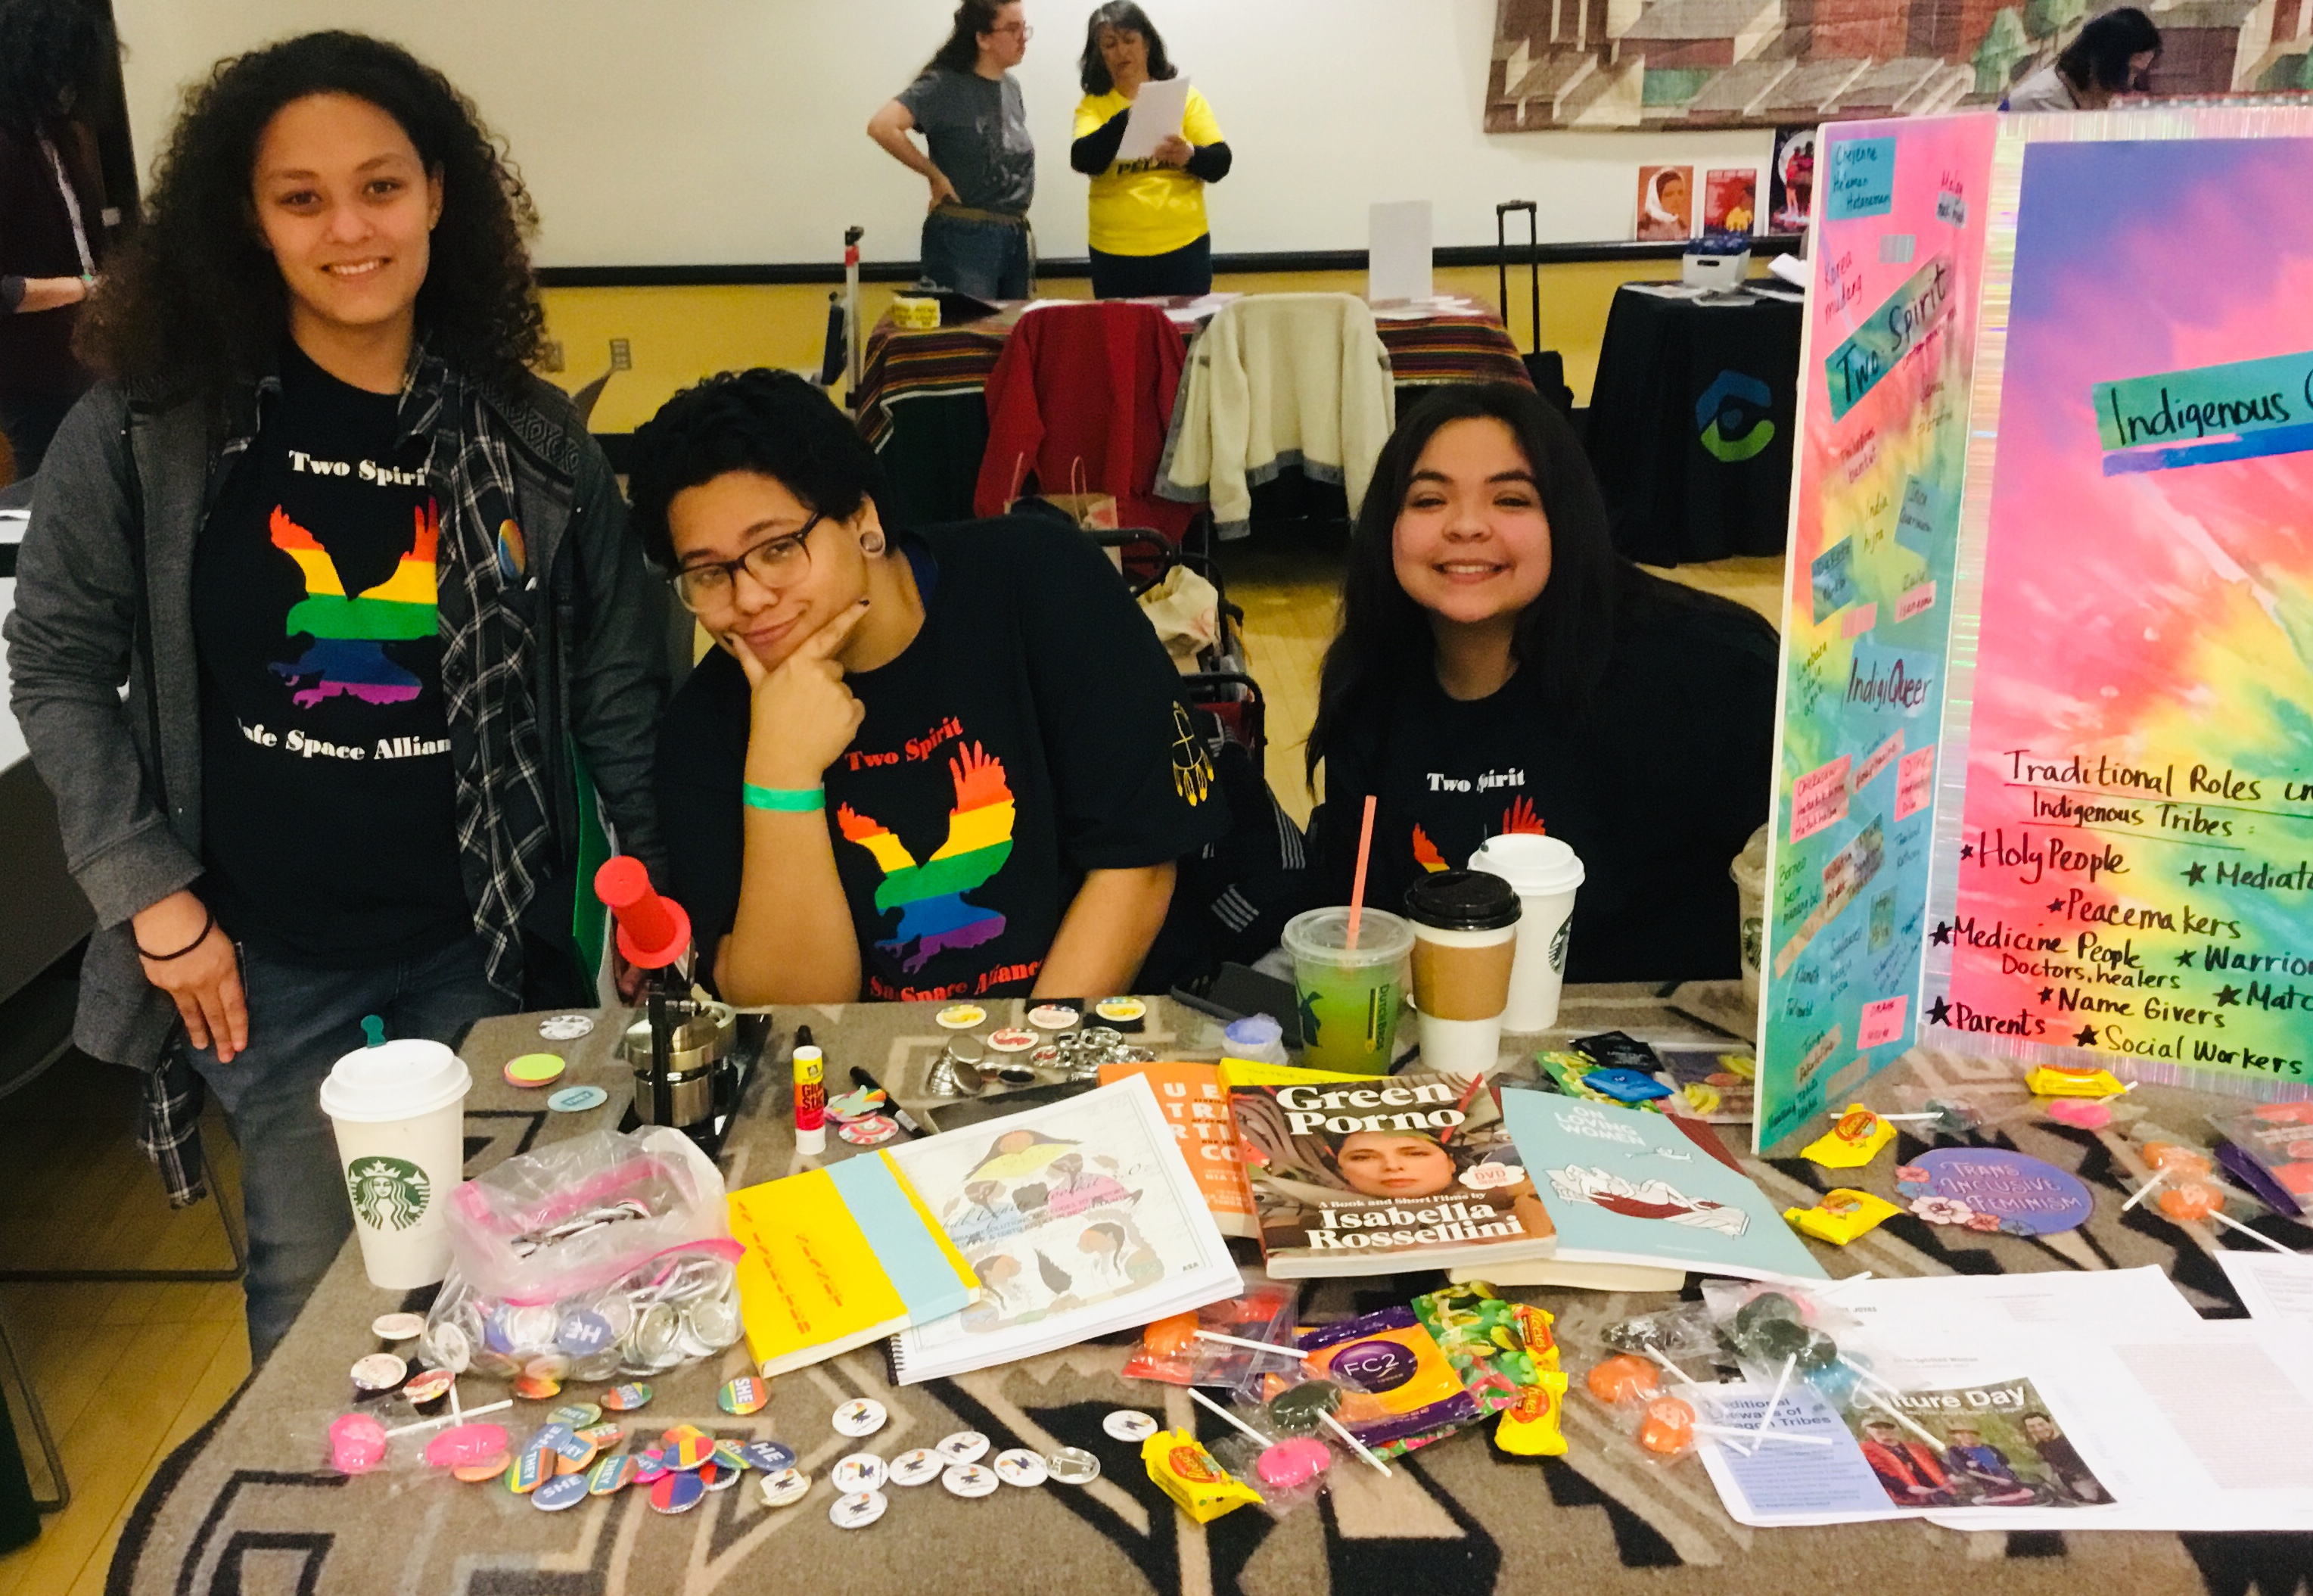 | Community & Advocacy  We’re now making strides for wider change and fun!
  Encourage Community to Integrate Inclusion in fun celebratory ways
  Inclusion & Visibility is Evident  (e.g. signage/ posters, display cases, brochures)  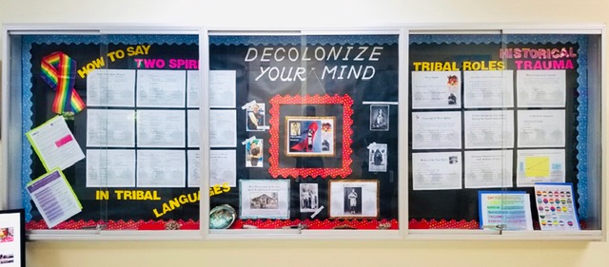 | - Upon Entry  - In the Hallways  - In the Staff Rooms  - In the Classrooms  - Gender neutral restrooms  - Grant 2S Safe Space
  Youth Driven  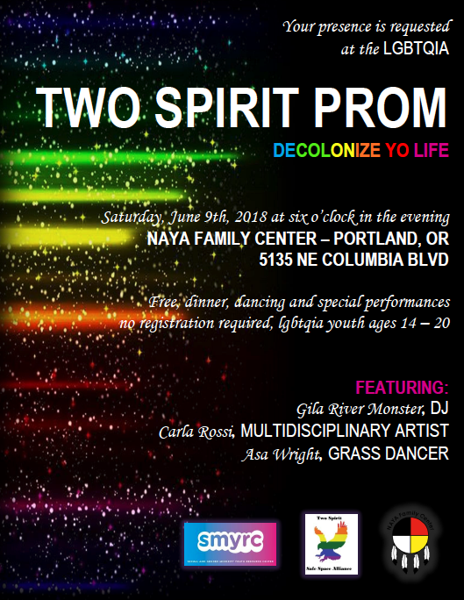 | - Create Two Spirit Safe Space Alliance  - Youth created logo’s  - Youth Tabled Events  - Two Spirit Prom  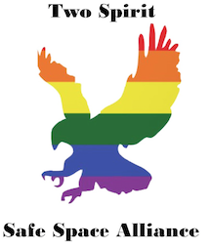
  Community Presence  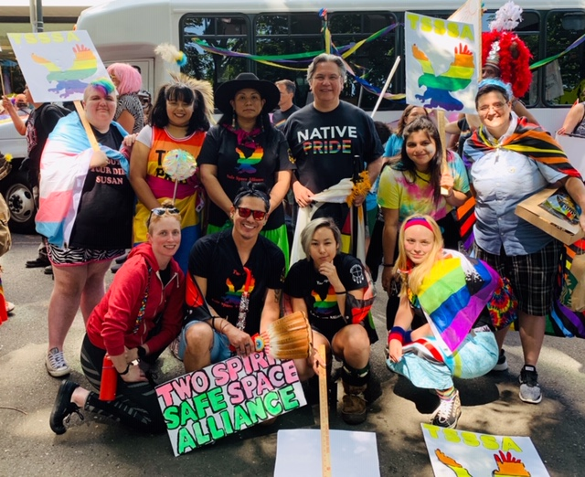 | - Rally’s  - Events  - T-shirts  - Ally posters, buttons, t-shirts

Reporting Back to the Community & Keeping Them Involved

Continue to build relationships with the community. By reporting back, inviting, and showing a consistent presence within the community your program and ultimately 2SLGBTQ will be better supported.
- How will you inform the community of the survey results, including your plans for how you will incorporate their feedback?

Reach Community Members (Invite Strategy) | Who’s Responsible?
- Newspapers/ Tribal Newsletter
- Local or Tribal Radio Station
- Social media
- Partner Channels (e.g. school, tribal clinic, Boys&Girls Club, etc.)
- Tribal Grapevine
- Email
- Other ways:

- Consider hosting or co-hosting regularly scheduled community events. Considering how often will you meet with your community group.
  - Once a year
  - Twice a year
  - Three times a year
  - Quarterly
  - Before, Middle, and After programming
  - Other:

- Can you co-host the event? (e.g. youth programs, school events, community events, tribal events, traditional foods or cultural department, etc.)

- If possible, schedule a pre-meeting to discuss ways you can collaborate and tag team this for future meetings. Who are you point of contacts for these groups?

- How will you keep the community engaged?
  - How will you re-engage the community group, if participation rates start to drop off?
  - Will you offer incentives? If so, what will you use; when will you give them out?

Sustainability Plan

Through this process, hopefully other community partners have organically become a part of this process. Think about how these partners can help sustain your efforts for 2SLGBTQ inclusive programming and services, if funding, staff turnover, or leadership change should affect your program.
A MAJOR benefit of working with your community is to utilize and share resources. By getting everyone in a room together you can build these relationships and see how you can support and share resources with each other.

- What are your plans for longer term program sustainability?
- Will you work with your organization to sustain and integrate your program as an ongoing effort?

- Do you plan to leverage community support?

- What community partners or programs might support your efforts?

- Are they willing to vet support from other groups?

