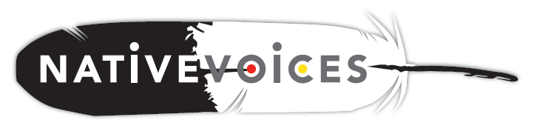

Instructions:
Please take a few minutes to answer the following questions about the Native VOICES video. Please answer as
truthfully as possible. There is no right or wrong answer. Your answers will help us improve the video’s use
for other AI/AN youth in the future. Thank you.

- What is your sex?
- Male
- Female
- Other (please describe): _____________________

- How old are you? (Please check one.)
- Younger than 15 years old
- 15 -17 years old
- 18 - 24 years old
- I am older than 24 years old

Please circle the answer in each row to describe how you feel about the Native VOICES video.
3 | Did you enjoy watching the Native VOICES video? | Yes |  | No |  | Don't know
4 | The quality of the video’s actors, editing,  and music were: | Excellent |  | Average |  | Poor
5 | Would you recommend this video to a friend? | Yes |  | No |  | Don’t know
6 | I think the information I got from this video was: | Right |  | Wrong |  | Don’t know
7 | I think the information I got from this video: | Can be trusted |  | Can’t be trusted |  | Don’t know
8 | I think the information I got from this video will help me make healthy life choices. | Yes |  | No |  | Don't know
9 | How does this video compare to other sexual health lessons that you’ve had? | Better |  | About the same |  | Worse

Do you agree or disagree with the following statements about the Native VOICES video.
10 | The video showed real-life situations with characters that I could relate to. |  |  | Agree |  | Disagree
11 | The video showed both partners (men and women) taking responsibility for negotiating condom use. |  |  | Agree |  | Disagree
12 | I could see myself or my friends in the same situations that were presented in the video. |  |  | Agree |  | Disagree
13 | Some of the things the actors did and said in the  video about condoms and negotiating safer sex  would work for me. |  |  | Agree |  | Disagree

- Do you think the Native VOICES video is culturally appropriate for American Indian people?
- Yes
- No

Comments:

- Did the Native VOICES video change your views about using condoms?
- Yes, I am more likely to use condoms
- Yes, I am less likely to use condoms
- No, my opinion did not change

- Did the Native VOICES video change your views about using dental dams?
- Yes, I am more likely to use dental dams
- Yes, I am less likely to use dental dams
- No, my opinion did not change

- Did the Native VOICES video change your views about getting tested for STDs/HIV?
- Yes, I am more likely to get tested for STDs/HIV
- Yes, I am less likely to get tested for STDs/HIV
- No, my opinion did not change

- Do you have any other comments that you would like to share with the video’s developers?

Thank you for your time!

